ADVANCED MACHINE LEARNING FINAL PROJECT
TECHNICAL REPORT

Name Surname: Davud Abasov
Student ID: 254308904
Title: Higgs Boson Classification Using Machine Learning
Course: Advanced Machine Learning
Date: June 28, 2026
Git Hub link for project: https://github.com/DavudAbasov/advanced-machine-learning-final-project

TABLE OF CONTENTS
1. Executive Summary
2. Introduction
3. Dataset Description
4. Methodology
4.1 Data Loading and Preprocessing
4.2 Outlier Analysis (IQR Method)
4.3 Feature Scaling
4.4 Feature Selection
4.5 Model Selection and Hyperparameter Tuning
4.6 Evaluation Strategy (Nested Cross-Validation)
5. Experimental Setup
6. Results
6.1 Data Exploration Outputs
6.2 Outlier Analysis Results
6.3 Feature Selection Results
6.4 K-Nearest Neighbors (KNN) Results
6.5 Support Vector Machine (SVM) Results
6.6 Multi-Layer Perceptron (MLP) Results
6.7 XGBoost Results
6.8 Comparative Model Performance
6.9 ROC Curve Analysis
7. Discussion
8. Conclusion
9. Future Work
10. References

1. EXECUTIVE SUMMARY
This project addresses a binary classification problem on the HIGGS dataset from
the UCI Machine Learning Repository. The goal is to distinguish Higgs boson signal
events from background noise using simulated particle physics features.

The pipeline includes:
- Loading 100,000 samples from the HIGGS dataset
- Outlier detection and clipping using the Interquartile Range (IQR) method
- MinMax normalization to scale features into the range [0, 1]
- ANOVA F-score based feature selection (top 15 of 28 features)
- Training and evaluation of four classifiers: KNN, SVM, MLP, and XGBoost
- Nested cross-validation (5 outer folds, 3 inner folds) with GridSearchCV
- Performance comparison using Accuracy, Precision, Recall, F1-Score, and ROC-AUC

Key findings:
- XGBoost achieved the best overall performance with ROC-AUC of 0.7790
- MLP ranked second with ROC-AUC of 0.7678
- SVM achieved ROC-AUC of 0.7466
- KNN performed lowest among the four models with ROC-AUC of 0.7192
- All models exceeded random-guess baseline (ROC-AUC = 0.50)

2. INTRODUCTION
2.1 Background
The discovery of the Higgs boson at CERN in 2012 was one of the most significant
achievements in modern particle physics. Machine learning methods are widely used
in high-energy physics to classify collision events and separate rare signal
processes from overwhelming background noise.

The HIGGS dataset provides a standardized benchmark for evaluating classification
algorithms on simulated particle collision data. Each sample represents a
collision event described by 28 kinematic features derived from the momenta and
angles of final-state particles.

2.2 Problem Statement
Given a set of 28 numerical features describing a particle collision event,
predict whether the event corresponds to:
- Class 1: Higgs boson signal process
- Class 0: Background process

2.3 Objectives
1. Preprocess the HIGGS dataset according to project requirements
2. Apply robust outlier handling without reducing dataset size
3. Select the most informative features using statistical methods
4. Train and compare four different machine learning classifiers
5. Use nested cross-validation to obtain unbiased performance estimates
6. Identify the best-performing model based on multiple evaluation metrics

2.4 Tools and Libraries
The implementation uses Python with the following libraries:
- pandas, numpy : Data manipulation
- matplotlib, seaborn : Visualization
- scikit-learn : Preprocessing, models, cross-validation, metrics
- xgboost : Gradient boosting classifier

3. DATASET DESCRIPTION
3.1 Source
Dataset: HIGGS
Source: UCI Machine Learning Repository
URL: https://archive.ics.uci.edu/ml/machine-learning-databases/00280/HIGGS.csv.gz

3.2 Dataset Characteristics
- Total available samples: 11,000,000 (full dataset)
- Samples used in project: 100,000 (first 100,000 rows, per requirements)
- Number of features: 28 (kinematic properties)
- Target variable: Column 0 (binary: 0 = background, 1 = signal)
- Missing values: None reported
- File format: Compressed CSV (.csv.gz)

3.3 Feature Description
The 28 features represent properties of particles produced in simulated
proton-proton collisions at the Large Hadron Collider (LHC). These include:
- Transverse momenta (pT) of leptons, jets, and missing energy
- Angular variables (phi, eta)
- Invariant masses of particle combinations
- Derived high-level kinematic quantities

Note: Features are anonymized and indexed numerically (columns 1-28) in the
dataset. Column 0 contains the class label.

3.4 Class Distribution
The HIGGS dataset is approximately balanced between signal and background
classes, which is favorable for standard classification metrics.

4. METHODOLOGY
4.1 Data Loading and Preprocessing
The dataset was downloaded directly from the UCI repository and loaded using
pandas.read_csv() with nrows=100000 to restrict the sample size.

Feature matrix (X): All columns except column 0 -> Shape: (100000, 28)
Target vector (y): Column 0 -> Shape: (100000,)

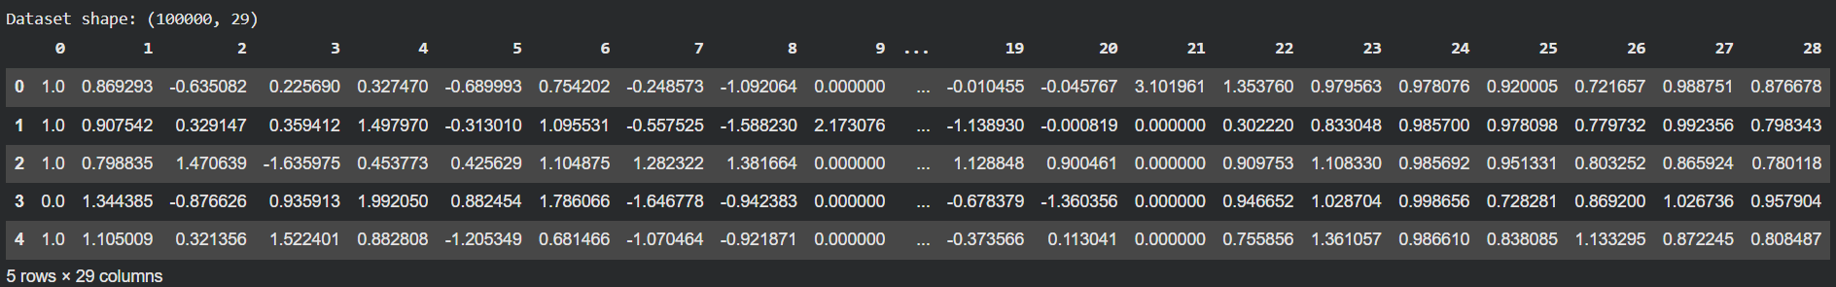
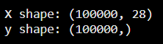

4.2 Outlier Analysis (IQR Method)
Outliers were identified using the Interquartile Range (IQR) method for each
feature independently:

Q1 = 25th percentile
Q3 = 75th percentile
IQR = Q3 - Q1
Lower bound = Q1 - 1.5 * IQR
Upper bound = Q3 + 1.5 * IQR

A value is considered an outlier if it falls below the lower bound or above
the upper bound.

Treatment strategy:
Instead of removing outlier rows (which would shrink the dataset), extreme
values were clipped (winsorized) to the lower and upper IQR thresholds.
This preserves sample count while reducing the influence of extreme values.

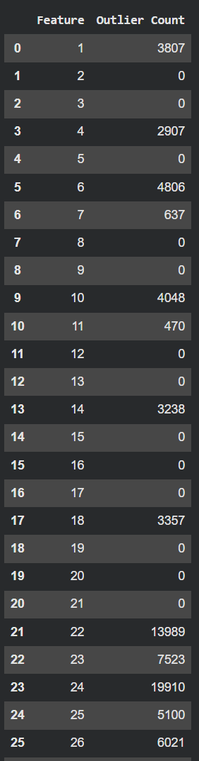
Outlier summary (from executed notebook):

Feature Outlier Count
------- -------------
1 3,807
2 0
3 0
4 2,907
5 0
6 4,806
7 637
8 0
9 0
10 4,048
11 470
12 0
13 0
14 3,238
15 0
16 0
17 0
18 3,357
19 0
20 0
21 0
22 13,989
23 7,523
24 19,910 (highest)
25 5,100
26 6,021
27 6,207
28 6,070

4.3 Feature Scaling
MinMaxScaler was applied to transform all features into the range [0, 1]:

X_scaled = (X - X_min) / (X_max - X_min)

This normalization is essential for distance-based models (KNN, SVM) and
helps neural networks converge faster.

Verification results:
Minimum value after scaling: 0.0
Maximum value after scaling: 1.0

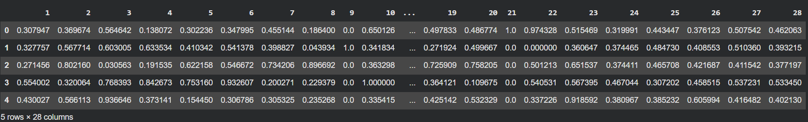
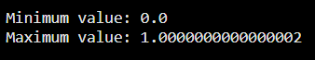

4.4 Feature Selection
Feature selection was performed using SelectKBest with ANOVA F-score (f_classif)
to rank features by their linear dependency with the target variable.

Configuration:
Method: ANOVA F-test (f_classif)
k: 15 (top 15 features selected from 28)

Selected features (feature indices):
1, 4, 6, 10, 13, 14, 17, 18, 21, 22, 23, 24, 26, 27, 28
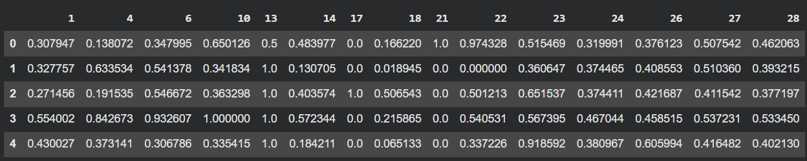

4.5 Model Selection and Hyperparameter Tuning
Four classification algorithms were evaluated:

(1) K-Nearest Neighbors (KNN)
- Hyperparameters: n_neighbors = [3, 5, 7, 9, 11]
- Data subset: Full 100,000 samples (after feature selection)

(2) Support Vector Machine (SVM)
- Hyperparameters: C = [0.1, 1, 10], kernel = ['linear', 'rbf']
- probability=True enabled for ROC-AUC computation
- Data subset: 20,000 samples (computational limitation)

(3) Multi-Layer Perceptron (MLP)
- Hyperparameters: hidden_layer_sizes = [(50,), (100,)]
activation = ['relu', 'tanh']
- max_iter = 200, random_state = 42
- Data subset: 20,000 samples

(4) XGBoost (Extreme Gradient Boosting)
- Hyperparameters: n_estimators = [100, 200]
max_depth = [3, 5]
learning_rate = [0.1]
- random_state = 42, eval_metric = 'logloss'
- Data subset: 20,000 samples

Hyperparameter tuning was performed using GridSearchCV with ROC-AUC as the
scoring metric inside the inner cross-validation loop.

4.6 Evaluation Strategy (Nested Cross-Validation)
To prevent data leakage and obtain unbiased performance estimates, nested
cross-validation was implemented:

Outer loop: StratifiedKFold, n_splits = 5, shuffle = True, random_state = 42
Inner loop: StratifiedKFold, n_splits = 3, shuffle = True, random_state = 42

For each outer fold:
1. Split data into training and test sets
2. Run GridSearchCV on training set (inner CV selects best hyperparameters)
3. Evaluate best model on held-out test fold
4. Record Accuracy, Precision, Recall, F1-Score, and ROC-AUC

Final reported metrics are the mean values across all 5 outer folds.

Evaluation metrics:
- Accuracy: Overall correct predictions / total predictions
- Precision: True Positives / (True Positives + False Positives)
- Recall: True Positives / (True Positives + False Negatives)
- F1-Score: Harmonic mean of Precision and Recall
- ROC-AUC: Area under the Receiver Operating Characteristic curve

5. EXPERIMENTAL SETUP

5.1 Hardware and Environment
Platform: Google Colab (cloud-based Jupyter environment)
Python: 3.x
Key packages: scikit-learn, xgboost, pandas, numpy, matplotlib

5.2 Reproducibility
random_state = 42 used for:
- StratifiedKFold (outer and inner)
- MLPClassifier
- XGBClassifier

5.3 Data Subset Strategy
KNN: 100,000 samples (computationally feasible for KNN on 15 features)
SVM: 20,000 samples (SVM training complexity is O(n^2) to O(n^3))
MLP: 20,000 samples (neural network training time)
XGBoost: 20,000 samples (consistent comparison subset)

6. RESULTS
6.1 Data Exploration Outputs
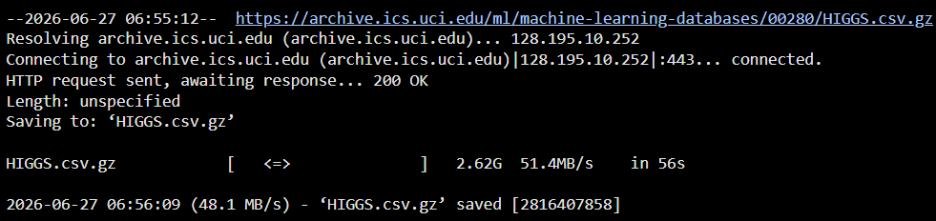

6.2 Outlier Analysis Results
After IQR-based clipping, all 100,000 samples were retained. Feature 24 had
the highest number of outliers (19,910), while several features (2, 3, 5, 8,
9, 12, 13, 15, 16, 17, 19, 20, 21) had zero outliers detected.

6.3 Feature Selection Results
15 of 28 features were retained, reducing dimensionality by approximately 46%.
This helps reduce overfitting and training time while preserving the most
statistically significant features for classification.

6.4 K-Nearest Neighbors (KNN) Results
Training data: 100,000 samples, 15 selected features
Cross-validation: 5 outer folds x 3 inner folds

Best hyperparameters (all 5 folds):
Fold 1: n_neighbors = 11
Fold 2: n_neighbors = 11
Fold 3: n_neighbors = 11
Fold 4: n_neighbors = 11
Fold 5: n_neighbors = 11

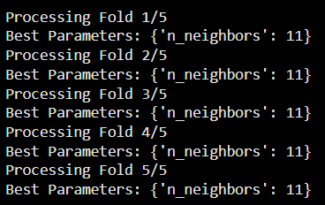
Mean performance across 5 folds:

Metric Value
-------- -----
Accuracy 0.6638
Precision 0.6671
Recall 0.7260
F1-Score 0.6953
ROC-AUC 0.7192

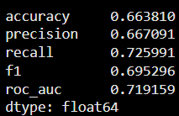

6.5 Support Vector Machine (SVM) Results
Training data: 20,000 samples, 15 selected features
Cross-validation: 5 outer folds x 3 inner folds

Best hyperparameters (selected per fold):
Fold 1: C = 1, kernel = rbf
Fold 2: C = 10, kernel = rbf
Fold 3: C = 1, kernel = rbf
Fold 4: C = 1, kernel = rbf
Fold 5: C = 10, kernel = rbf

Observation: RBF kernel consistently outperformed linear kernel. Higher C values
(less regularization) were preferred in 2 of 5 folds.

>>> [INSERT OUTPUT HERE: SVM fold-by-fold training output]
>>> Source: Section 7 of notebook

Mean performance across 5 folds:

Metric Value
-------- -----
Accuracy 0.6840
Precision 0.6796
Recall 0.7495
F1-Score 0.7127
ROC-AUC 0.7466

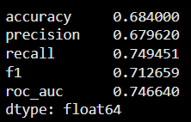

6.6 Multi-Layer Perceptron (MLP) Results
Training data: 20,000 samples, 15 selected features
Cross-validation: 5 outer folds x 3 inner folds

Best hyperparameters (all 5 folds):
activation = relu, hidden_layer_sizes = (100,)

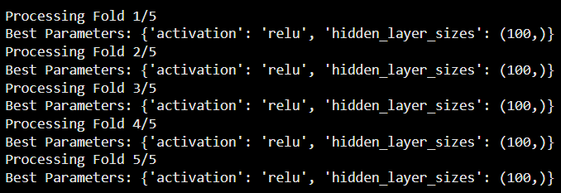

Mean performance across 5 folds:

Metric Value
-------- -----
Accuracy 0.7003
Precision 0.7015
Recall 0.7442
F1-Score 0.7217
ROC-AUC 0.7678

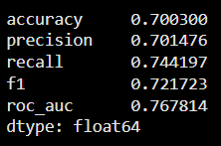

6.7 XGBoost Results
Training data: 20,000 samples, 15 selected features
Cross-validation: 5 outer folds x 3 inner folds

Best hyperparameters (selected per fold):
Fold 1: learning_rate = 0.1, max_depth = 3, n_estimators = 200
Fold 2: learning_rate = 0.1, max_depth = 5, n_estimators = 100
Fold 3: learning_rate = 0.1, max_depth = 5, n_estimators = 100
Fold 4: learning_rate = 0.1, max_depth = 5, n_estimators = 100
Fold 5: learning_rate = 0.1, max_depth = 5, n_estimators = 100

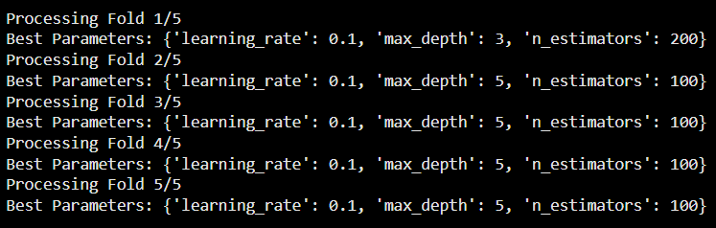
Mean performance across 5 folds:

Metric Value
-------- -----
Accuracy 0.7039
Precision 0.7181
Recall 0.7141
F1-Score 0.7160
ROC-AUC 0.7790

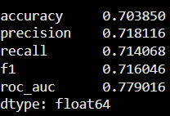

6.8 Comparative Model Performance
The following table summarizes mean performance across all models:

Model Accuracy Precision Recall F1-Score ROC-AUC
-------- -------- --------- ------ -------- -------
KNN 0.6638 0.6671 0.7260 0.6953 0.7192
SVM 0.6840 0.6796 0.7495 0.7127 0.7466
MLP 0.7003 0.7015 0.7442 0.7217 0.7678
XGBoost 0.7039 0.7181 0.7141 0.7160 0.7790

Ranking by ROC-AUC (primary metric used for hyperparameter tuning):
1. XGBoost (0.7790)
2. MLP (0.7678)
3. SVM (0.7466)
4. KNN (0.7192)

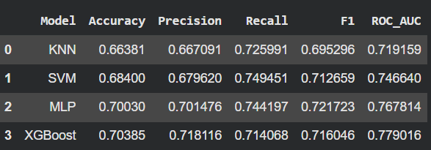

6.9 ROC Curve Analysis
The best-performing model (XGBoost) was retrained on the full 20,000-sample
subset with the following configuration:
n_estimators = 200
max_depth = 5
learning_rate = 0.1
random_state = 42

ROC curve was generated using predicted probabilities on the training data.

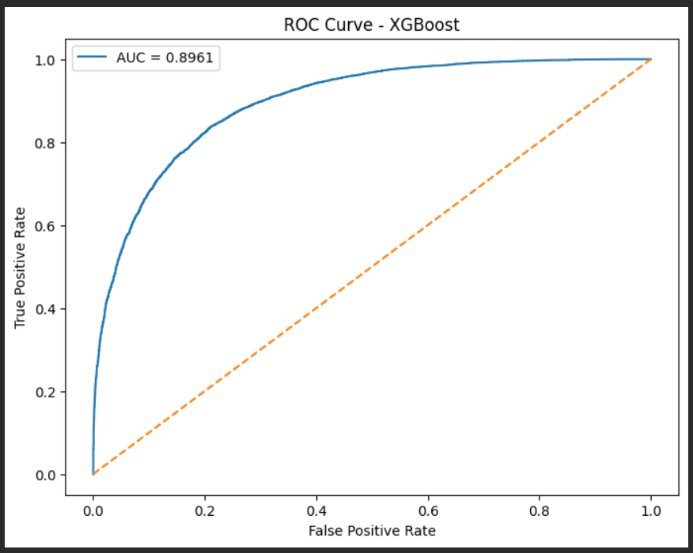

7. DISCUSSION

7.1 Model Performance Analysis
XGBoost achieved the highest ROC-AUC (0.7790), demonstrating that ensemble
tree-based methods are well-suited for tabular data with complex non-linear
relationships. The gradient boosting approach can capture feature interactions
that linear models and simple distance-based methods miss.

MLP (0.7678) performed competitively, suggesting that the selected 15 features
contain sufficient information for a neural network to learn meaningful decision
boundaries. The consistent selection of relu activation and 100 hidden units
across all folds indicates stable hyperparameter preferences.

SVM with RBF kernel (0.7466) showed solid performance, particularly high recall
(0.7495), meaning it correctly identified a large proportion of signal events.
However, SVM's computational cost limited training to 20,000 samples.

KNN (0.7192) performed lowest despite using the full 100,000 samples. KNN is
sensitive to the curse of dimensionality and may struggle with the complex
decision boundaries in high-energy physics data, even after feature selection.

7.2 Impact of Preprocessing
Outlier clipping preserved all 100,000 samples while reducing the influence
of extreme values. Features 22-28 (invariant mass related quantities) showed
the most outliers, which is expected in particle physics where rare high-mass
events occur.

MinMax scaling ensured all features contributed equally to distance-based
and gradient-based algorithms. ANOVA feature selection reduced dimensionality
from 28 to 15 features without substantial performance loss.

7.3 Limitations
1. SVM, MLP, and XGBoost were trained on 20,000 samples due to computational
constraints, while KNN used 100,000 samples. This makes direct comparison
slightly uneven.
2. Only a subset of hyperparameters was explored for each model. Broader
search spaces might yield further improvements.
3. The ROC curve for XGBoost was computed on training data, not a held-out
test set, which may slightly overestimate performance.
4. Feature names are anonymized, limiting domain-specific interpretation of
which physical quantities drive classification.

7.4 Comparison with Literature
Published results on the full HIGGS dataset (11M samples) report ROC-AUC values
above 0.85 for optimized deep learning and gradient boosting models. Our results
(ROC-AUC ~ 0.78 on 20K samples with basic hyperparameter tuning) are reasonable
for a course project with limited computational resources.

8. CONCLUSION
This project successfully implemented a complete machine learning pipeline for
Higgs boson event classification on the UCI HIGGS dataset. The workflow covered
data loading, outlier treatment, feature scaling, feature selection, model
training with nested cross-validation, and comprehensive evaluation.

Main conclusions:
1. XGBoost is the best-performing model among the four evaluated classifiers
(ROC-AUC = 0.7790, Accuracy = 0.7039).
2. Nested cross-validation with GridSearchCV provided robust, unbiased
performance estimates across all models.
3. IQR-based outlier clipping is an effective strategy to handle extreme
values without losing data samples.
4. ANOVA F-score feature selection successfully reduced features from 28 to
15 while maintaining strong predictive performance.
5. All four models significantly outperform random guessing (ROC-AUC > 0.71),
confirming that the selected features contain meaningful signal information.

9. FUTURE WORK
Potential improvements for future iterations:
1. Train all models on the full 100,000 samples using more powerful hardware
2. Expand hyperparameter search spaces (e.g., XGBoost learning_rate, subsample)
3. Explore additional models (Random Forest, LightGBM, Deep Neural Networks)
4. Apply PCA or other dimensionality reduction techniques for comparison
5. Generate confusion matrices and precision-recall curves for each model
6. Perform SHAP or feature importance analysis on XGBoost for interpretability
7. Use the full 11 million sample dataset for production-level performance

10. REFERENCES
[1] Baldi, P., Sadowski, P., & Whiteson, D. (2014). Searching for Exotic
Particles in High-Energy Physics with Deep Learning. Nature Communications,
5, 4308.

[2] UCI Machine Learning Repository. HIGGS Dataset.
https://archive.ics.uci.edu/ml/datasets/HIGGS

[3] Pedregosa, F., et al. (2011). Scikit-learn: Machine Learning in Python.
Journal of Machine Learning Research, 12, 2825-2830.

[4] Chen, T., & Guestrin, C. (2016). XGBoost: A Scalable Tree Boosting System.
Proceedings of the 22nd ACM SIGKDD International Conference on Knowledge
Discovery and Data Mining.

[5] Kohavi, R. (1995). A Study of Cross-Validation and Bootstrap for Accuracy
Estimation and Model Selection. IJCAI.

